Scout Master:

Scout Master Mike Poelzer comes from a large Seattle family. Once a scout himself, he has never actually left his childhood. Having tasted scouting as a youth, and participating in his own son’s cub pack and scout troop, he has been the cornerstone of this troop since 2002.

Mike is fully engaged in making this boy run program flourish. He encourages boys of all backgrounds and abilities to grow in the scouting program.

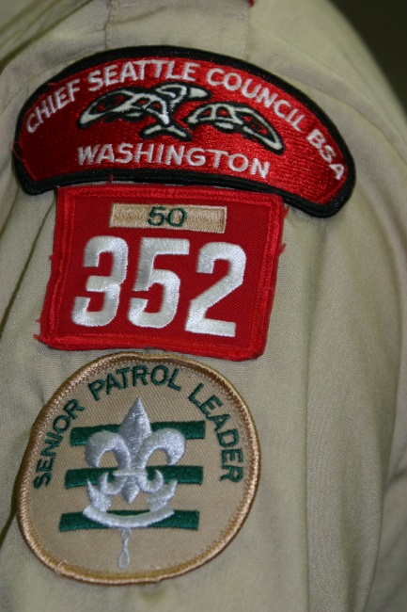

Come see for yourself!

We encourage interested boys and parents to visit our program. All are welcome to drop in on any Monday evening to see if Boy Scout Troop 352 is a good fit for your scout.

A Scout is…

Trustworthy

Loyal

Helpful

Friendly

Courteous

Kind

Obedient

Cheerful

Thrifty

Brave

Clean

Reverent

Boy Scout Troop 352

**Established in 1953**

Boy run program

Weekly meetings

Monthly outings

Annual activities calendar

Service projects

Cultural diversity

Long history of Eagle Scout achievements

We are a fun and dynamic troop committed to youth leadership development, safety, encouraging the boys to reach Eagle, guided by the Scout Oath and Law.

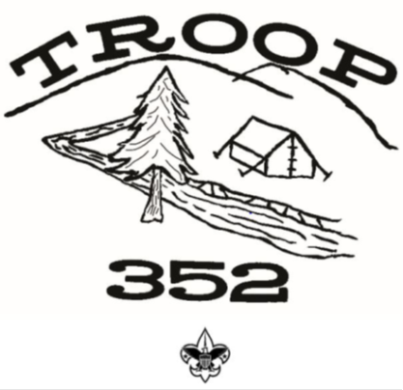

Troop Committee Chairman

(206) 819-6026

Join Today!!

Join Today!!

Youth wishing to join our troop and who meet the eligibility requirements on the Boy Scout Membership Application are welcome to join and will receive a troop 352 Joining Packet.

Requirements:

Boys between the age of 11 and 18 years old, or have completed the 5th grade, or have earned the Arrow of Light are eligible for troop enrollment.



Who:

Boys seeking fun, leadership skills, lifetime friendships, the great outdoors and more!!

What:

Leadership Friendship

Backpacking Cycling

Camping Swimming

Archery Canoeing

Cooking Fishing

First Aid Pioneering

Sports Scout Skills

…and much, much more!

When:

Weekly Meetings

Mondays from 7:00pm to 8:30pm

Where:

Highline United Methodist Church

13015 1st Ave S, Burien, WA, 98168

(Basement Fellowship Hall)

Why:

This troop is boy led and has more fun and activities than most troops! Boys learn lifelong skills, and leadership in a dynamic, fun, environment encouraging the trail to Eagle.

Adult Volunteer Opportunities:

Consider getting involved with a fun and rewarding position within the troop such as:

Troop Committee Chairman

Charter Organization Rep

Secretary

Treasurer

Advancement Chair

Communications Director

Fund Raising Director

Equipment Director

Outdoor/Activities Director

Training Coordinator

Scouting Coordinator

Create your own needed position

Troop Committee contact information:

Troop Committee Chair: Martin Fore (206) 819-6026

Scout Master: Mike Poelzer (206) 618-2008

Asst. Scout Master: Kevin Hall

Charter Representative: Don Anderson

Treasurer: Sue Fore (206) 819-6017

Advancement Chair: Bob Jones

Quartermaster: Dean Dyson

Recruitment Coordinator: Gail James

Visit us at: *http://troop352wa.ScoutLander.com*